**MUSIC WORLD**

**Index1.html**

<!DOCTYPE html>

<html>

<head>

<title>Music World a Entertainment </title>

<!--fonts-->

<link href='http://fonts.googleapis.com/css?family=Fredericka+the+Great' rel='stylesheet' type='text/css'>

<link href='http://fonts.googleapis.com/css?family=Lato:100,300,400,700,900,100italic,300italic,400italic,700italic,900italic' rel='stylesheet' type='text/css'>

<!--//fonts-->

<link href="css/bootstrap.css" rel="stylesheet">

<link href="css/style.css" rel="stylesheet" type="text/css" media="all" />

<!-- js -->

<script type="text/javascript" src="js/jquery.min.js"></script>

<!-- js -->

</head>

<body>

<!-- header -->

<div class="header">

<div class="container">

<div class="header-left">

<a href="index.html">Music World</a>

</div>

<div class="navigation">

<nav class="navbar navbar-default">

<div class="navbar-header">

<button type="button" class="navbar-toggle collapsed" data-toggle="collapse" data-target="#bs-example-navbar-collapse-1">

<span class="sr-only">Toggle navigation</span>

<span class="icon-bar"> </span>

<span class="icon-bar"> </span>

<span class="icon-bar"> </span>

</button>

</div>

<div class="collapse navbar-collapse nav-wil" id="bs-example-navbar-collapse-1">

<ul class="nav navbar-nav">

<li class="hvr-bounce-to-bottom active"><a href="index1.html">HOME <span class="sr-only">(current)</span></a></li>

li class="hvr-bounce-to-bottom"><a href="about.html">ABOUT</a></li>

<li class="hvr-bounce-to-bottom"><a href="album.html">ALBUM</a></li>

<li class="hvr-bounce-to-bottom"><a href="contact.html">CONTACT</a></li>

<li class="hvr-bounce-to-bottom"><a href="jio.html">ADD MEMBER</a></li>

</ul>

<div class="clearfix"> </div>

</div><!-- /.navbar-collapse -->

</nav>

</div>

<div class="clearfix"></div>

</div>

</div>

<!-- //header -->

<!-- banner -->

<div class="banner">

<div class="container">

<script src="js/responsiveslides.min.js"></script>

<script>

$(function () {

$("#slider").responsiveSlides({

auto: true,

nav: true,

speed: 500,

namespace: "callbacks",

pager: true,

});

});

</script>

<div class="caption">

<div class="slider">

<div class="callbacks_container">

<ul class="rslides" id="slider">

<li><h3>THE MUSIC WORLD</h3></li>

<li><h3>WORLDS BEST MUSIC</h3></li>

<li><h3>JEEVAJOTHI's MUSIC</h3></li>

</ul>

<p>Which Have You Never Seen Before!!</p><br><br><br><br><br></div>

</div></div></div>

<!-- //banner -->

<!-- banner-bottom -->

<div class="banner-bottom">

<div class="container">

<div class="bottom-grids">

<div class="col-md-3 bottom-one">

<div class="bottom-text">

<h3>MORDEN MUSIC</h3>

<p>Morden music is

stored your heart</p>

</div>

</div>

<div class="col-md-3 bottom-two">

<div class="bottom-text">

<h3>HIP HOP MUSIC</h3>

<p>hip hop is a

freezeable moment</p>

</div>

</div>

<div class="col-md-3 bottom-four">

<div class="bottom-text">

<h3>FOLK MUSIC</h3>

<p>Folk music is momentable music </p>

</div>

</div>

<div class="clearfix"></div>

</div>

</div>

</div><br>

<!-- //banner-bottom -->

<!-- welcome -->

<div class="welcome">

<div class="container">

<div class="welcome-head">

<h3>WELCOME</h3>

<p><font color="white">Welcome to Jeevajothi and Manibarathi 's music world. This website contains all categorys of music</font></p>

</div>

</div>

</div>

<!-- //welcome -->

<!-- popular -->

<div class="popular">

<div class="container">

<div class="popular-head">

<h3>MY ALBUM</h3>

</div>

<div class="popular-grids">

<div class="col-md-4 popular-grid">

<img src="images/9.jpg" alt=""/>

<div class="pop-desc">

<p>MODERN MUSIC</p>

</div>

</div>

<div class="col-md-4 popular-grid">

<img src="images/8.jpg" alt=""/>

<div class="pop-desc">

<p>HIP HOP MUSIC</p>

</div>

</div>

<div class="col-md-4 popular-grid">

<img src="images/113.jpg" alt=""/>

<div class="pop-desc">

<p>FOLK MUSIC</p>

</div>

</div>

<div class="clearfix"></div>

</div>

</div>

</div>

<!-- //popular -->

<!-- //full -->

<!-- footer -->

<!-- //footer -->

<!-- copy -->

<div class="copy-right">

<div class="container">

<p> &copy; 2018 Music World. All Rights Reserved | Design by <a href="http://Jeevajothi.com/"> Jeevajothi</a></p>

</div>

</div>

<!-- copy -->

</body>

</html>

**Iraivaa.html**

<htlml>

<head>

<title>iraiva</title>

<script language="javascript"> function gourl() { window.history.go(-1); } </script>

</head>

<body bgcolor="lightblue">

<p align="center">

<img src="images\007.jpg" width="400" height="400" ><br><br>

<audio src="audio\Iraiva.mp3" controls="true"> </audio><br><br>

<input type="button" value="BACK" onclick=gourl()><br><br>

</p>

© 2018 Music World. All Rights Reserved | Design by Jeevajothi

</body>

</html>

**Karuthavallam.html**

<htlml>

<head>

<title>karuthavallam</title>

<script language="javascript"> function gourl() { window.history.go(-1); } </script>

</head>

<body bgcolor="grey">

<p align="center">

<img src="images\005.jpg" width="750" height="400" ><br><br>

<audio src="audio\Karuthavanlam.mp3" controls="true"> </audio><br><br>

<input type="button" value="BACK" onclick=gourl()><br><br>

© 2018 Music World. All Rights Reserved | Design by Jeevajothi

</body>

</html>

**Vaa.html**

<htlml>

<head>

<title>Vaa velaikkara</title>

<script language="javascript"> function gourl() { window.history.go(-1); } </script>

</head>

<body bgcolor="lightyellow">

<p align="center">

<img src="images\006.jpg" width=" 300" height="400" ><br><br>

<audio src="audio\Vaa.mp3" controls="true"> </audio><br><br>

<input type="button" value="BACK" onclick=gourl()><br><br>

© 2018 Music World. All Rights Reserved | Design by Jeevajothi

</body></html>

**Member.jsp**

<%@page contentType="text/html" pageEncoding="utf-8" %>

<!DOCTYPE html>

<html>

<head>

<title>members</title>

</head>

<body align="center" bgcolor="lime">

<form action="insert.jsp">

<h1>MUSIC MEMBERS</h1>

<table align="center" border="10" bgcolor="#4f8r">

<tr>

<td><label>

Enter your name</label>

<td>

<input type="text" placeholder="Enter your name" name="name"><br></tr>

<tr><td><label>

Enter your address</label>

<td><input type="text" placeholder="Enter your address" name="address"><br></tr>

<tr><td><label>

Email address</label>

<td><input type="email" placeholder="Enter your email" name="email"><br></tr>

<tr><td><label>

phone no</label>

<td><input type="text" placeholder="number" name="phoneno"><br></tr>

<tr>

<td><input type="submit" value="save">

</tr>

</table>

</form>

</body>

</html>

**Insert.jsp**

<%@ page import ="javax.sql.*"%>

<%@page import="java.sql.Statement"%>

<%@page import="java.sql.DriverManager"%>

<%@page import="java.sql.Connection"%>

<%@page contentType="text/html" pageEncoding="UTF-8"%>

<!DOCTYPE html>

<html>

<head>

<style>

#id1{font-family:French Script MT;font-size:72pt;color:brown;}

#id2{font-size:22pt;}

</style>

<meta http-equiv="Content-Type" content="text/html; charset=UTF-8">

<title>Insertion Suceeded</title>

</head>

<body bgcolor="skyblue" align="center">

<%

String name=request.getParameter("name");

String add=request.getParameter("address");

String email=request.getParameter("email");

String phoneno=request.getParameter("phoneno");

try

{

Class.forName("com.mysql.jdbc.Driver");

Connection con=DriverManager.getConnection("jdbc:mysql://localhost:3306/student","root","123456");

Statement st=con.createStatement();

st.executeUpdate("insert into stud(name,address,email,phoneno)values('"+name+"','"+add+"','"+email+"','"+phoneno+"')");

%>

<p id="id1">Record Inserted Successfully</p>

<a href="index1.html" id="id2">Home</a>

<%

con.close();

}

catch(Exception e)

{

out.println(e);

}

%>

<br><a href="register.jsp" id="id3"> SHOW TABLE</a>

</body>

</html>

**Register.jsp**

<%@page import="java.sql.DriverManager"%>

<%@page import="java.sql.ResultSet"%>

<%@page import="java.sql.Statement"%>

<%@page import="java.sql.Connection"%>

<%

String driver = "com.mysql.jdbc.Driver";

String connectionUrl = "jdbc:mysql://localhost:3306/";

String database = "student";

String userid = "root";

String password = "123456";

try {

Class.forName(driver);

} catch (ClassNotFoundException e) {

e.printStackTrace();

}

Connection connection = null;

Statement statement = null;

ResultSet resultSet = null;

%>

<!DOCTYPE html>

<html>

<head><style>

#id1{font-family:Lucida Calligraphy;font-size:22pt;color:red;}

#id2{font-family:Lucida Handwriting;font-size:18pt;color:blue;}

#id3{font-size:22pt;}

</style></head>

<body>

<p align="center">

<font size="+5" face="Algerian" color="green">

Records for</font>

</p>

<table border="25" align ="center" cellspacing="5" width="900">

<tr>

<th id="id1">Name</th>

<th id="id1">Address</th>

<th id="id1">email</th>

<th id="id1">Phoneno</th>

</tr>

<%

try{

connection = DriverManager.getConnection(connectionUrl+database, userid, password);

statement=connection.createStatement();

String sql ="select * from stud ";

resultSet = statement.executeQuery(sql);

while(resultSet.next()){

%>

<tr>

<td id="id2"><%=resultSet.getString("name") %></td>

<td id="id2"><%=resultSet.getString("address") %></td>

<td id="id2"><%=resultSet.getString("email") %></td>

<td id="id2"><%=resultSet.getString("phoneno") %></td>

</tr>

<%

}

connection.close();

} catch (Exception e) {

e.printStackTrace();

}

%>

<down><a href="index.html">Home</a>

</down>

</table>

</body>

</html>

**Screen shots**

**Index1.html**

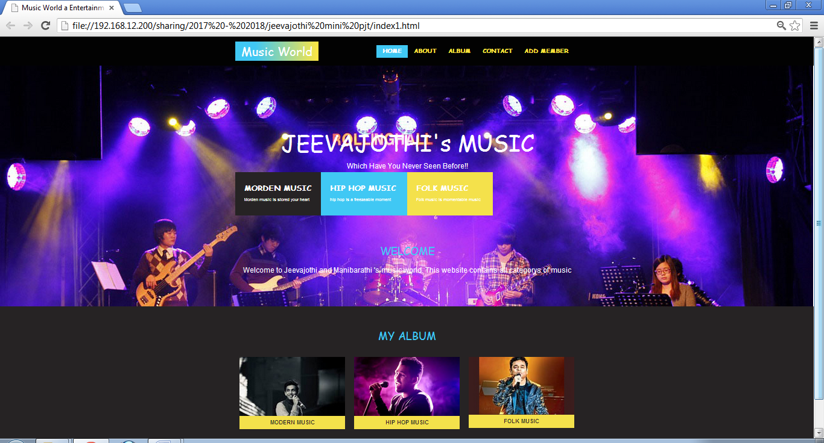

**About.html**

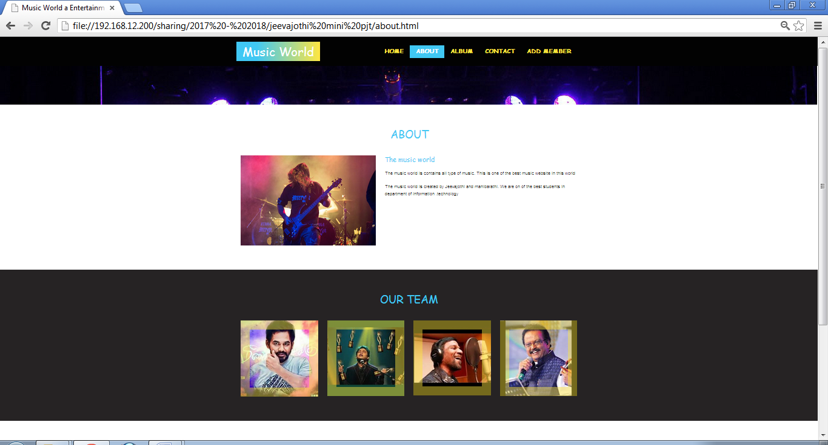

**Album.html**

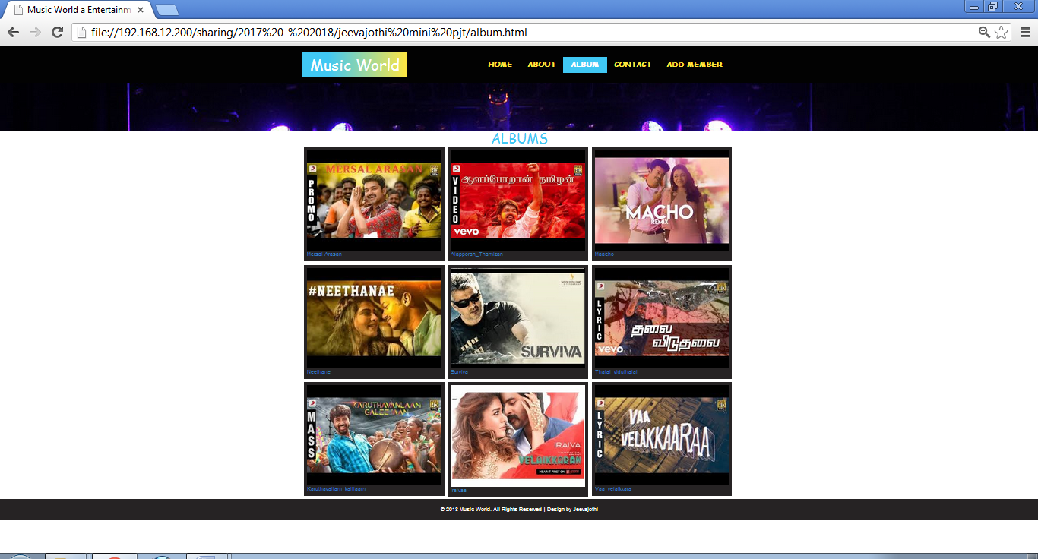

**Contact.html**

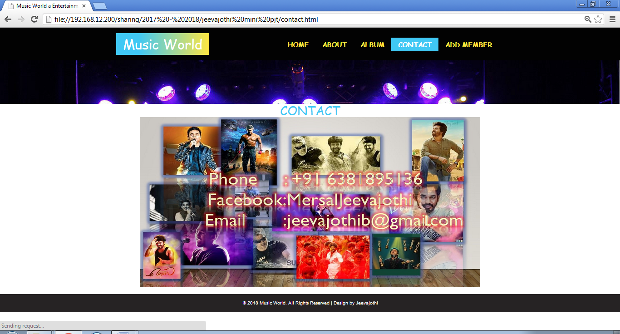

**Mersal_arasan.html**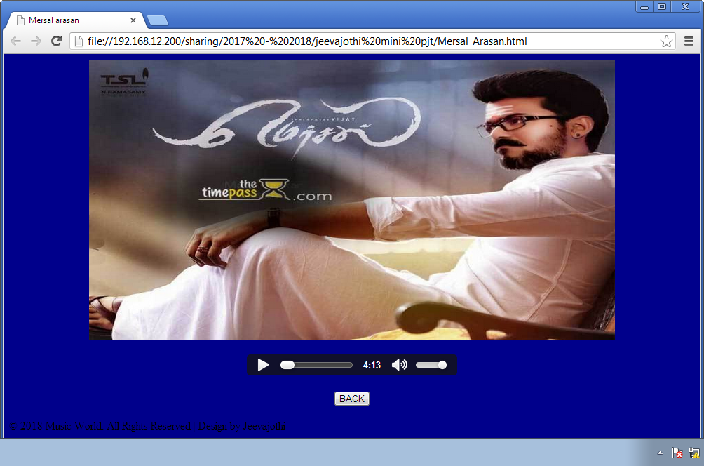

**Surviva.html**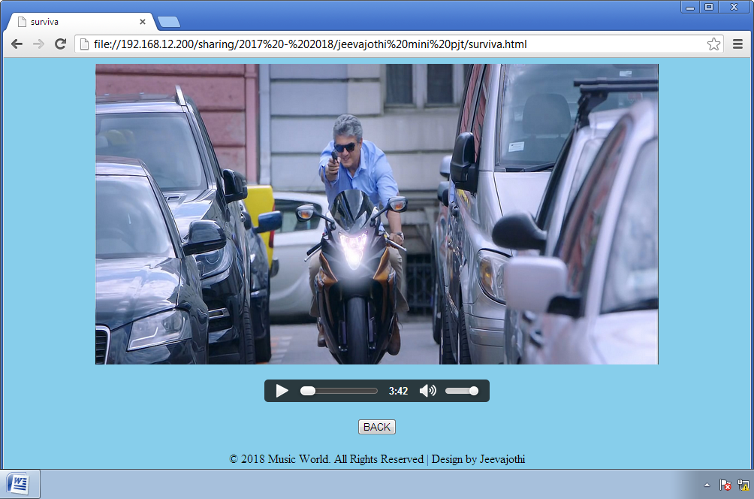

**Thalai.html**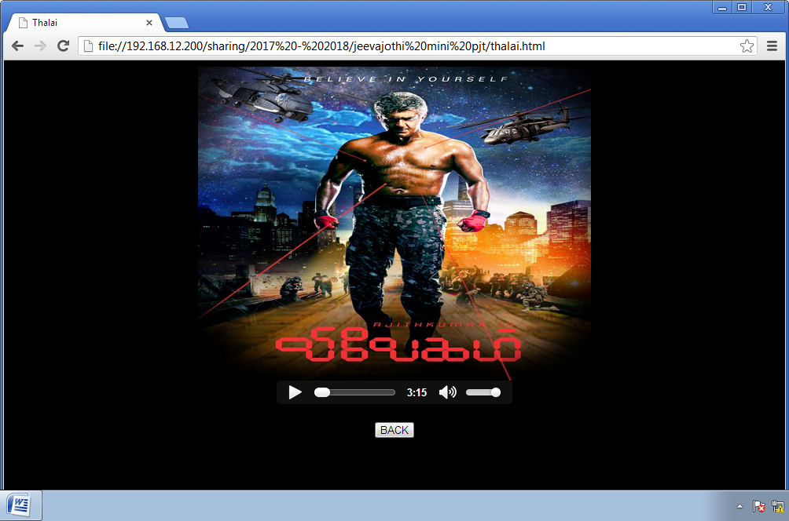

**Member.jsp**

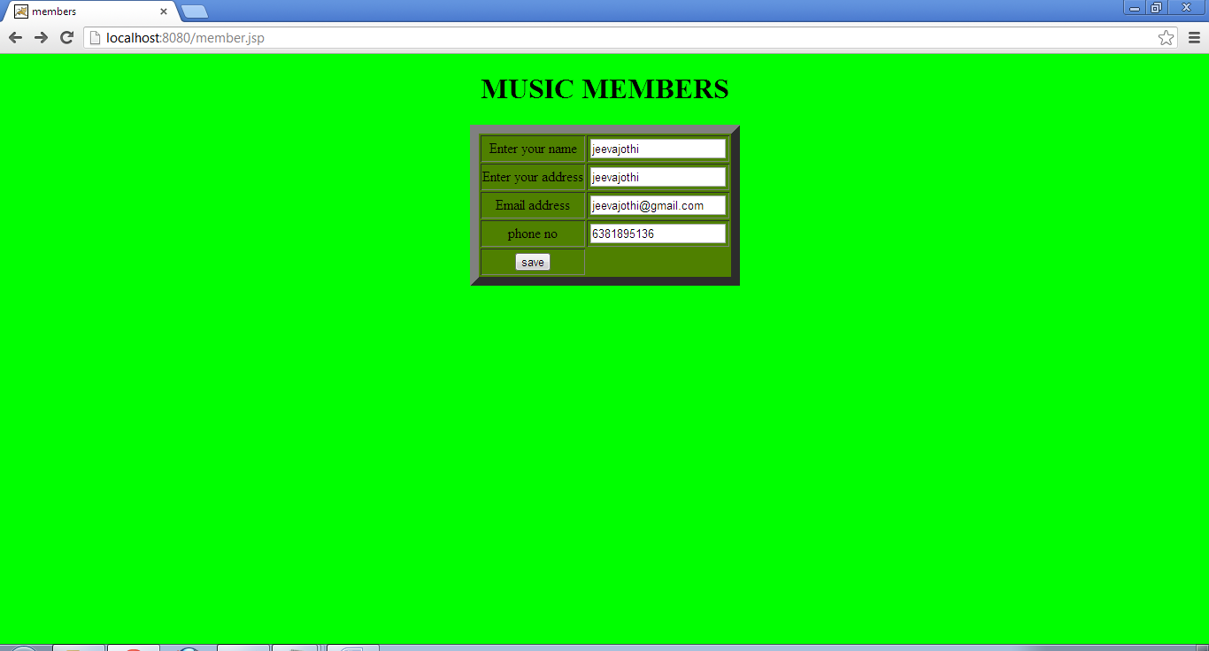

**Insert.jsp**

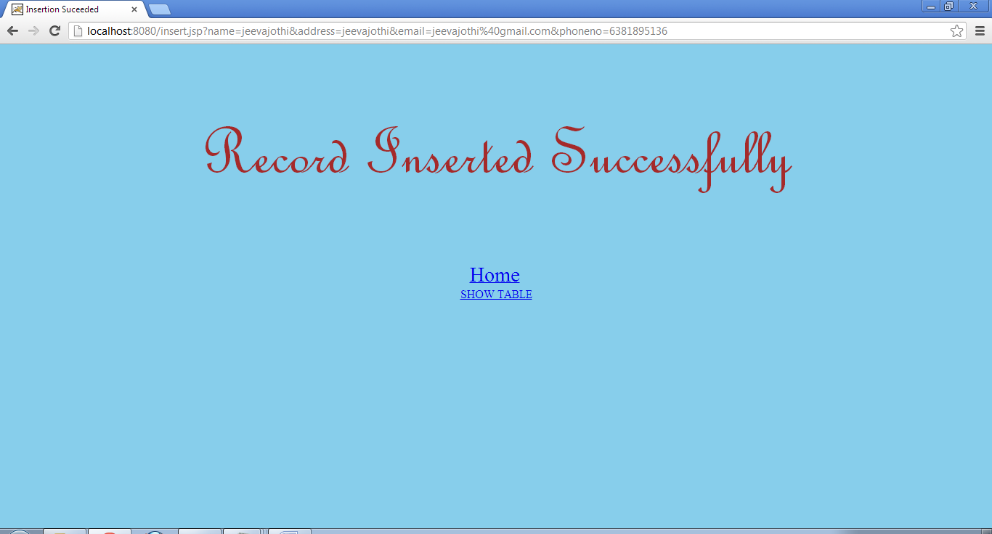

**Register.jsp**

